L6 Cyber Security Labs Guide

*To be used as a troubleshooting guide for L6 Groups K, L, I, J. From Week 3 onwards, no more environment setups or fixes will be done in class. Please refer to the lab setup guide on Blackboard in conjunction with this guide and set up your machines if you haven’t already.*

Most labs require you to have your **Kali**, **OWASP VM**, and occasionally also your **Windows VM** running at the same time. These machines need to be on the same network in order to communicate with each other.

This is how the network typically looks like.

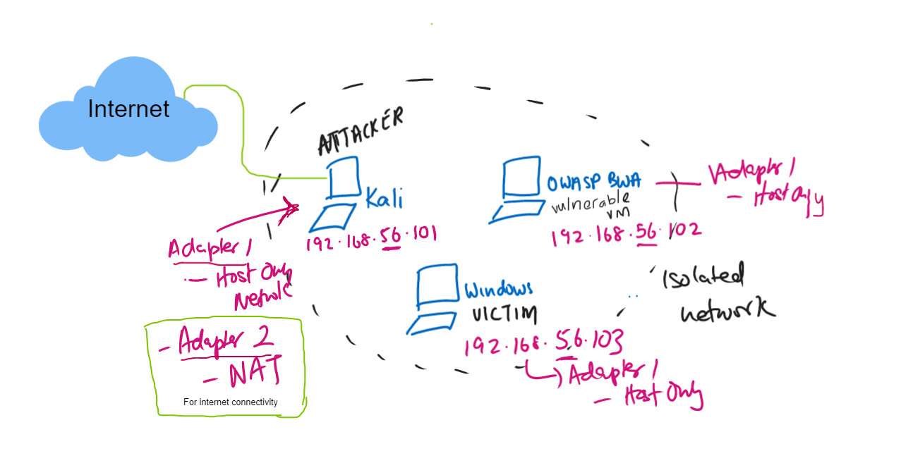

To be on the same network and communicate with each other, all networks should have **Host-Only Network** as their adapter. This creates an isolated network.

Only the Kali machine would need internet connectivity because it needs to install / update some packages tools on its machine. **Make sure that the other two VMs are not connected to the internet at any point.**

Since Kali needs internet connectivity, we add ‘NAT’ as the Adapter 2 in the Kali VM.

Here is the breakdown:

| **MACHINE** | **ROLE** | **IP** | **Internet connect?** | **Network Adapters** |
| --- | --- | --- | --- | --- |
| KALI | Attacker | 192.168.56.101 | YES | Adapter 1: Host-Only Network  Adapter 2: NAT |
| OWASP VM | Vulnerable Machine / Victim | 192.168.56.102 | NO | Adapter 1: Host-Only Network |
| Windows VM | Victim | 192.168.56.103 | NO | Adapter 1: Host-Only Network |

# User Credentials

Here are the user credentials to access these three VMs.

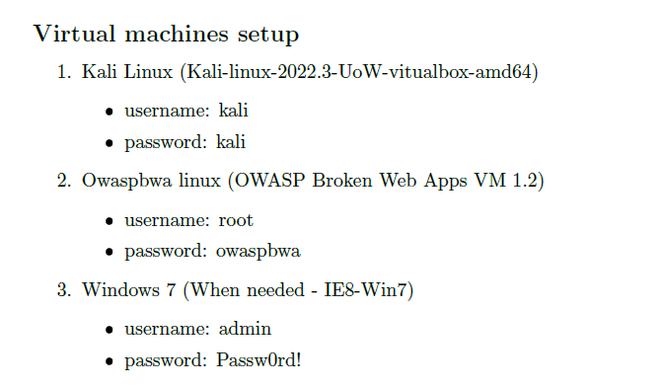

# VirtualBox Settings

## Setting up the virtual network adapter

1. In VirtualBox, Go to File -> Host Network Manager.

If there are no adapters to be found, create an adapter with the following settings. Sometimes, by default there may be an adapter already existing. In this case, you don’t need to create a new adapter. Just change the settings of the current one to match below.

These should be the settings for the virtual adapter.

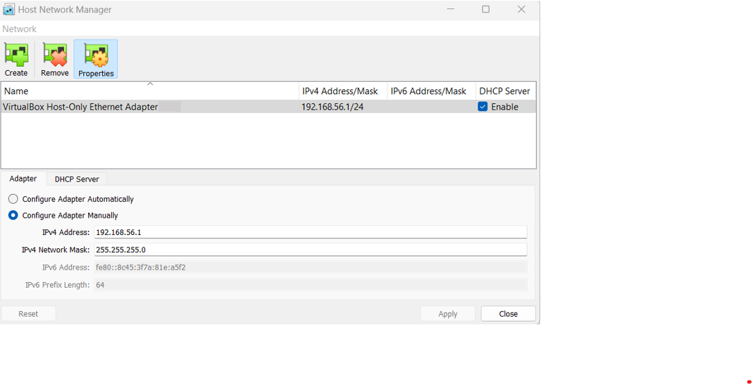

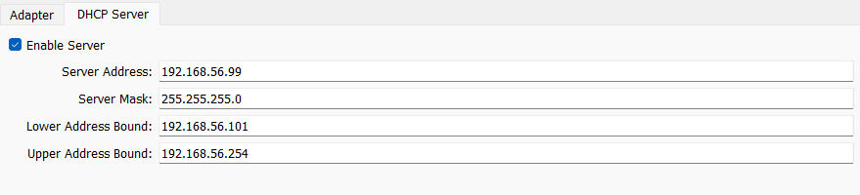

By doing the above steps, we are creating a **DHCP server** at address 192.168.56.99. A DHCP Server is responsible for handing out IP addresses to machines/hosts that join a network. We are also instructing here that any IPs that should be assigned to a particular machine that joins the network should be within the range of 192.168.56.**101** and 192.168.56.**254**.

## Enabling Network Adapters for the VMs

### Kali VM

* Click on Kali VM and click on the settings and add the following adapters under ‘Network’ tab.
* Adapter 1 should be set to Host-Only
* Adapter 2 should be set to NAT

**NOTE: You cannot make changes to VM settings when the VM is running. Always close the VM if its currently running and make changes to settings.**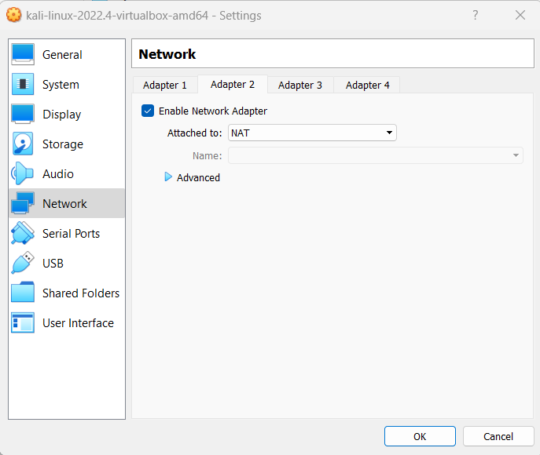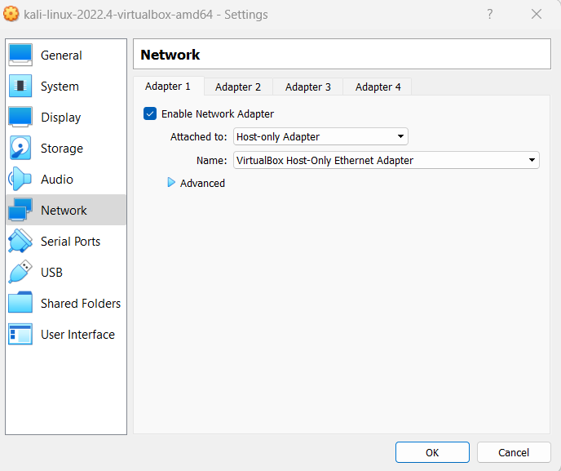

* Open the Kali VM, go to the firefox browser and check if you access the internet.

### OWASP VM

* Click on OWASP VM and click on Settings and add the following adapters under ‘Network’ tab.
* Only Adapter 1 should be enabled. Set it to Host-Only

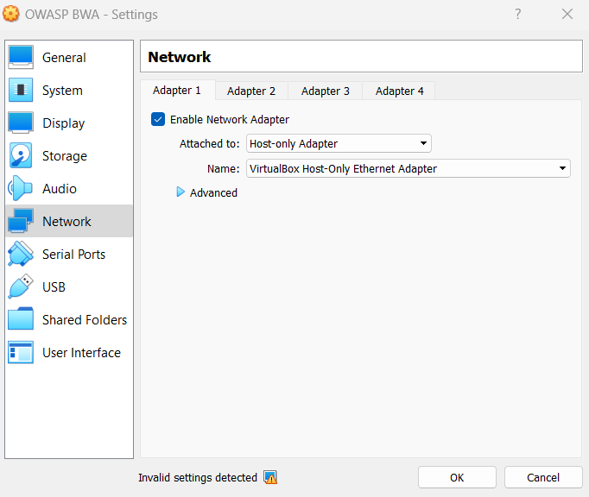

### Windows VM

* Click on Windows VM and click on Settings and add the following adapters under ‘Network’ tab.
* Only Adapter 1 should be enabled. Set it to Host-Only

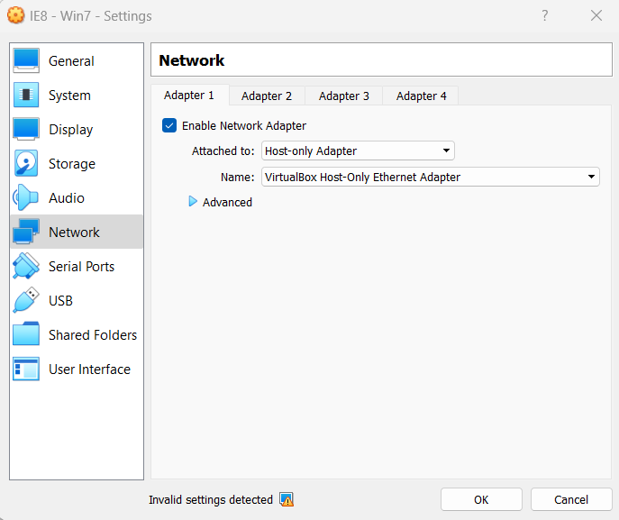

## Setting up Static IPs for the VMs

Currently with the given settings all hosts who join the isolated network (when you start the VMs) will be given IPs dynamically by the DHCP server. This means the three VMs will have dynamic IPs. This is given out at random. For instance Kali may get 192.168.56.101 today, but on another day when you spin up the Kali VM it may get another IP like 192.168.56.102. Since the labs always assume that Kali is at 192.168.56.101 and OWASP Vm is .102 and Windows is .103, it is better to set static IPs so we can always make sure these IPs will be constant and not change.

### Kali Linux VM

* To set up a static IP, type this command into the terminal

**sudo nano /etc/network/interfaces**

* This will open up the interfaces file in the nano text editor.
* Add this entry to the file to instruct to use static IP of 192.168.56.101:

auto eth0

iface eth0 inet static

address 192.168.56.**101**

netmask 255.255.255.0



**NOTE: The 0 in eth0 is basically the digit zero (0). It should not be confused with the alphabet letter O**.

**If you want to comment some line out you can add the # symbol in front of that line.**

* It should look **exactly** like this:

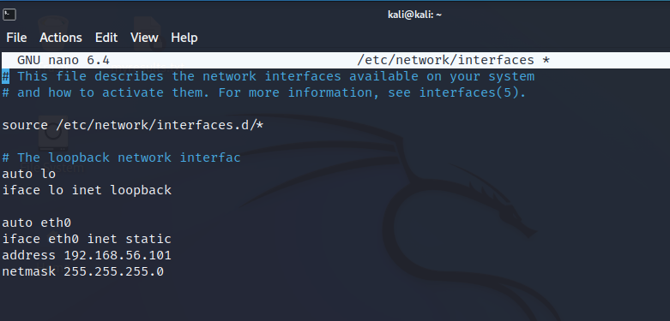

**NOTE: In some instances, there might already be an entry for auto eth0 and it might be set to dhcp (eg: iface eth0 inet dhcp). Remove or comment out (using # in the front) or edit those lines to reflect the information as given in the screenshot above.** **Basically there should only be one entry for eth0 and it should be set to static.**

* To save the file (in windows) =>

Press **Ctrl + X** to exit file

Type **y** to save

Press **enter** to save to file

* To check if contents were saved in the file type the command =>

**cat /etc/network/interfaces**

### OWASP VM

Repeat the same steps as previously done on Kali.

* Type into terminal to open and edit file

**sudo nano /etc/network/interfaces**

* Add the following content into it. Here we set the static IP to 192.168.56.102.

auto eth0

iface eth0 inet static

address 192.168.56**.102**

netmask 255.255.255.0



**NOTE: The 0 in eth0 is basically the digit zero (0). It should not be confused with the alphabet letter O**.

**If you want to comment some line out you can add the # symbol in front of that line.**

* It should look **exactly** like this:

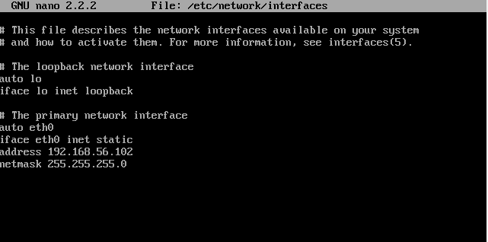



**NOTE: In some instances, there might already be an entry for auto eth0 and it might be set to dhcp (eg: iface eth0 inet dhcp). Remove or comment out (using # in the front) or edit those lines to reflect the information as given in the screenshot above.** **Basically there should only be one entry for eth0 and it should be set to static.**

### Windows VM

Follow these steps to set up the static IP on your windows vm.

* Go to Control Panel -> Network and Sharing center -> View network status and tasks
* Click on ‘Local Area Connection 2’
* Click on Properties
* Click on ‘Internet Protocol Version 4 (TCP/IPv4)’
* Click on Properties
* Add the config as shown in screenshot.

# Best Practices

## Daily Tutorial Ritual

* Download your lab tutorial for the day before hand
* Read the first page of your tute to find out the VMs you will be needing to use in the class.
* Start the VMs and check the IPs of each to check if they are on the same network and their IPs are correct.
  + Use the command **ifconfig** (on linux) or the **ipconfig** (on windows) to check the IP address of the VM.
  + If the IPs dont match the ones given on Page 1, then go through this guide again properly and set up the IPs correctly.
* Ping between the machines to see if they are up and running using the **ping** command.
* Try to fix issues as early as possible otherwise you would be wasting time and not learning the real thing.

## Backing Up Your VM (Taking a snapshot)

Snapshots allow you to save a particular state of a VM; this can be handy when you want to test something, or you’re about to make a change to that VM, and you need to be able to roll back to a working instance. If you need to save the configuration of a virtual machine so you can revert back to it later if something goes awry, create a snapshot.

* Click on the VM and from the menu bar click on Snapshot -> Take. Give a name for your snapshot and it will be saved. (screenshot on next page).
* Now whenever you want to go back to this snapshot, you can click on Restore and you can go back.

**NOTE : Don’t take snapshots unnecessarily. They may end up using up your disk space.**

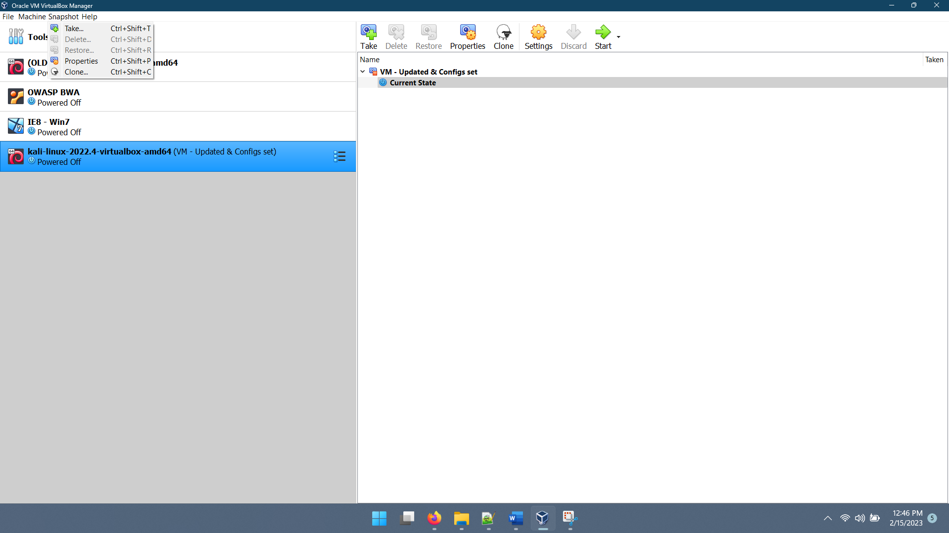

## Enable Copy, Paste, Drag and Drop operations between VM and Hosts

1. Click on the interested VM and go to settings.
2. Add the following settings.

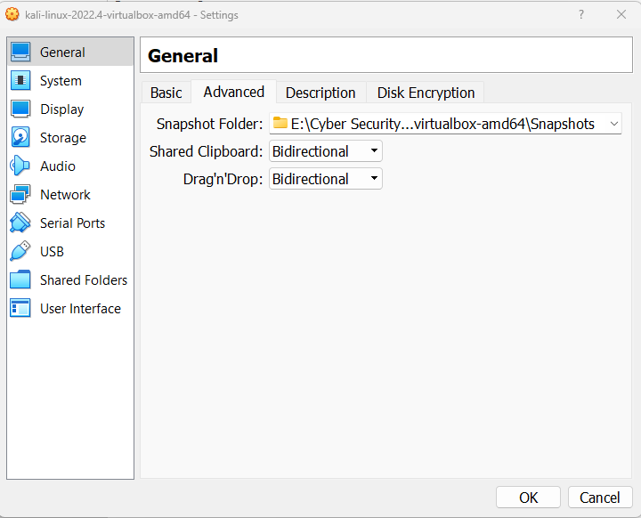

## Troubleshooting

**ISSUE 1: IP changes not reflecting.**

1. Reboot your VM using the command **reboot** in your linux terminal or power off the machine and then restart it and check if it solves your problem.
2. If the IPs still don't match the ones given on Page 1, then go through this guide again and **carefully read the instructions again** and set it up. Check spellings, in all the configurations.

**ISSUE 2: I ran a linux command as given in the tutorial sheet but I am getting (permission) errors.**

* Type **sudo** in front of the command and see if it works.
* If it’s a service that requires internet communication, check if you are connected to the internet.

**ISSUE 3: KALI vm hangs or doesn’t get past the loading screen**

Some reasons could be:

* You have other high resource applications running on your computer taking up machine resources.
* Computer is running low specs and cannot open up the vm.

Things you could try

* Restarting your computer.
* Try to change some configs. For example, increase base memory, processor CPU cores for your VM under settings. Use caution while increasing it within the red range because then your computer may hang or crash. Try to play around with configs within the green range.

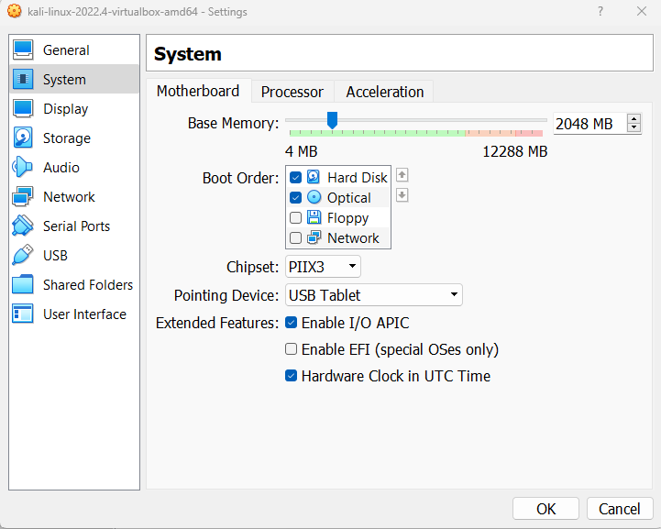

**ISSUE 4: OWASP vm never opens. It gets stuck on the black screen with commands without entering the login prompt on the screen. You have waited for a looooong time and nothing seems to change. You have tried closing and opening the vms again and again but nothing works.**

This issue is on your host Windows laptop running Windows 11 or 10. The reason could be:

* You have “memory integrity” checked on your settings. Check [this article](https://steemit.com/boinc/@lumendan/windows-10-core-isolation-prevents-virtualbox-from-using-hardware-virtualization-features) to read more about it.

Do the following (at your own risk)

* Select **Start** , enter ‘Core Isolation’ in the taskbar, and select **Core Isolation** from the list of results to open the Windows security app.
* On the Core isolation page, turn off the toggle for **Memory Integrity**. Restart your device. 

**NOTE: If you find better fixes for any of the issues listed in this guide, let me know.**

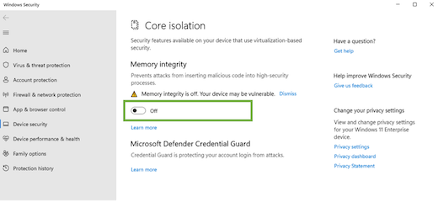

**ISSUE 5: VMs are toooooooooooo (emphasis on the oooooooooo) slow and hasn’t started up properly since I started working on the labs**

* Fixes in Issue 4 may help you (Disabling memory integrity)
* If your VMs are too slow to even get into the VMs, [read this article](https://www.sysprobs.com/fixed-virtualbox-vms-too-slow-on-windows-host) and make changes at your own risk.

**ISSUE 6: HELP! I clicked inside my vm and now I have lost my cursor!**

* Press the Right Ctrl key. Your mouse and keyboard will be released from the VM.

**ISSUE 7: I have a totally different problem.**

* Get help from Myself, Danishka Sir, Google or ChatGPT. Your pick.

**ISSUE 8: This guide is too long. Is there a TL;DR?**

* Yes, [here](http://www.quickmeme.com/img/3d/3d380730238e000701d62cd7bcc86e7fb3f7ab033724f53a005d1efc382e3666.jpg)